NS3 Home Tasks

- Packet size: 128
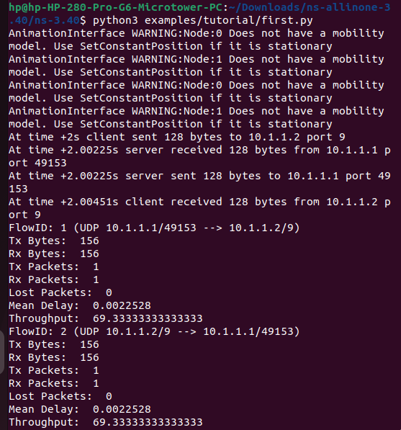

- Packet size: 256
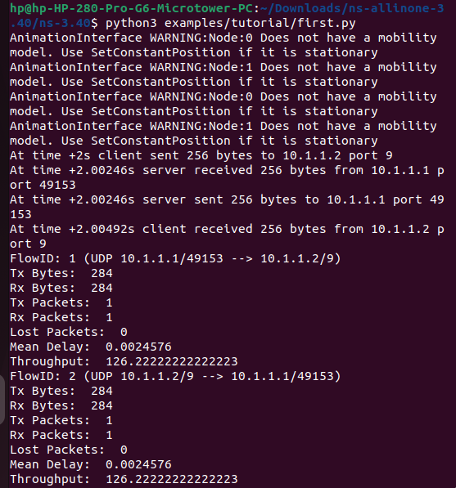

- Packet size: 512
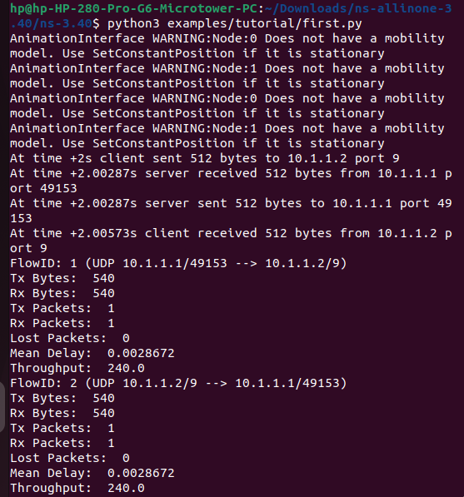

- Packet size: 1024
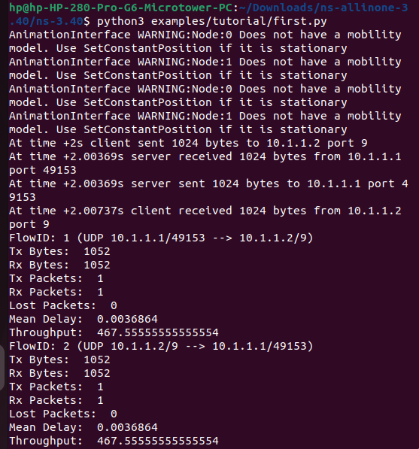

- Packet size: 2048
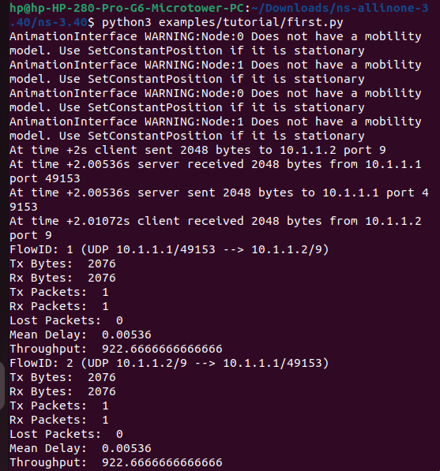

Graph using the above packet size and throughput values
Throughput vs Data size:

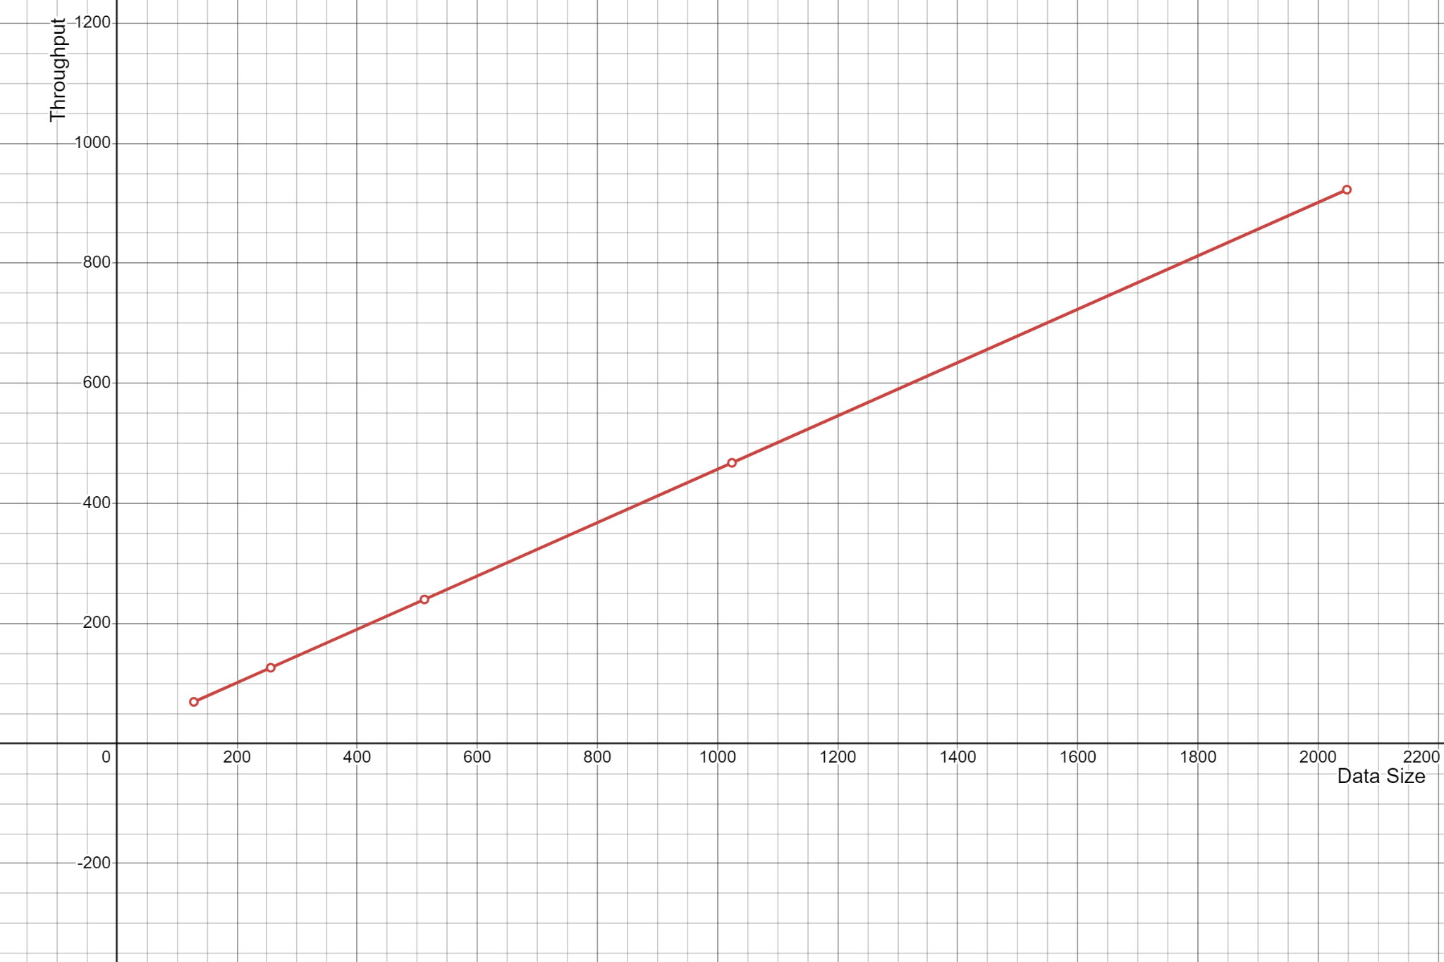

The graph illustrates a linear relationship between Data Size (x-axis) and Throughput (y-axis). The red line has a positive slope, indicating that as the Data Size increases, the Throughput also increases proportionally. This trend suggests that the system processes data more effectively as the data size grows. Larger data sizes likely allow the system to utilize its resources more efficiently, resulting in improved throughput performance. This proportional growth highlights how the system scales well with increasing data sizes.

